Sport Mode Fixed Dedicated RTT – CD391 V6 Engine Specific with CCD Fault Warning – CGEA1.3

Functional Description

All programs that support a VDM (Vehicle Dynamics Module), also called CCD (Continuously Controlled Damping) suspension module normally follow the “CCD Control Function w Adaptive Drive - CGEA1.3” STSS.
However, on 2016 CD391 with a V6 Engine, we have a greatly simplified cluster interface for CCD. There is no cluster menu selection. Instead, there is only the CCD Fault warning (necessary anytime you have a VDM) and a Sport Mode RTT when PRNDS is in “S”.

To be complete for CD391 (Ford with V6 engine), this STSS will also include the CCD Fault (W1027) logic that is part of “CCD Control Function w Adaptive Drive - CGEA1.3” STSS.

Note that the standard “Sport Mode Fixed Dedicated RTT” STSS could not be used on this program since Powertrain does not support the necessary signals for Adaptive Drive.

The purpose of the Sport_Mode_RTT is to inform the driver that they are a vehicle “Sport” mode of some type.

The Sport_Mode_RTT correlates the CcdMsgTxt_D_RqDsply signal and the Operational_Mode to illuminate or extinguish the Sport Mode RTT.

The Sport_Mode_RTT shall provide an iconic representation that will illuminate or extinguish to inform the driver whether or not they are in a “Sport” mode on an automatic transmission vehicle.

This section describes the RTT function and sets a flag that is used by the Message Center display (See Message Center Section for details of Message Display Algorithm).

Interfaces

Interface Context Diagram (I/O Block Diagram)
Figure 1. Sport Mode RTT Indication with CCD Fault
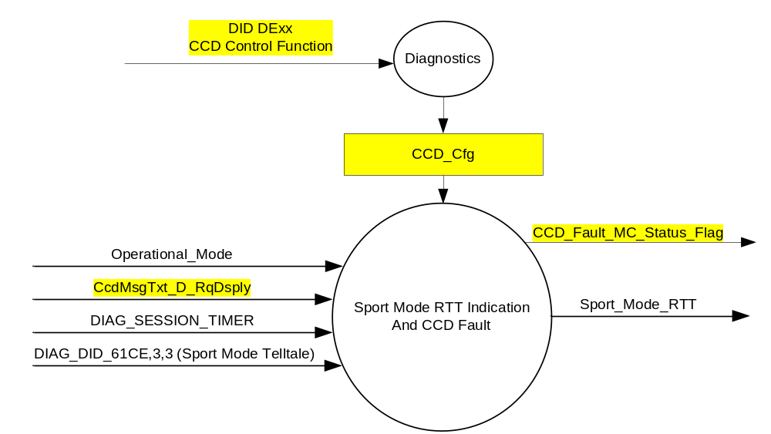

Inputs
      - INTERNAL:
            - CCD_Cfg (Also defined in “CCD Control Function w Adaptive Drive - CGEA1.3” STSS)
            - DIAG_SESSION_TIMER
            - Operational_Mode
      - DIAG_DID_61CE,3,3 (Sport Mode Telltale)
      - MUX message on the CAN Bus from PCM/TCM

- CcdMsgTxt_D_RqDsply Signal
Signal Name | Size (bits) | Detail | Units | Res. | Offset | State Encoded | Min | Max
CcdMsgTxt_D_RqDsply | 3 |  | SED | 1 | 0 |  | 0  (0x0) | 7  (0x7)
 |  | No_Mode_Selected |  |  |  | 0 (0x0)
 |  | Comfort |  |  |  | 1 (0x1)
 |  | Normal |  |  |  | 2 (0x2)
 |  | Sport |  |  |  | 3 (0x3)
 |  | Faulted |  |  |  | 4 (0x4)
 |  | CCD_Service_Required |  |  |  | 5(0x5)
 |  | CCD_Temporarily_Off |  |  |  | 6 (0x6)
 |  | Mode_Change_Unavailable |  |  |  | 7 (0x7)

Outputs
- Sport_Mode_RTT, which is used to control the state of the Reconfigurable Telltale
- CCD_Fault_MC_Status_Flag

Function/Performance

Operational Modes

Mode | Differentiating Vehicle Conditions
Sleep Mode | Sport_Mode_RTT = Inactive
Limited Mode | Sport_Mode_RTT = Inactive
Normal Mode | Sport_Mode_RTT = Active/Inactive
Crank Mode | Sport_Mode_RTT = Active/Inactive

The above table references the setting of the RTT flag as per this section. However, the actual RTT display operational modes are displayed in the Message Center section of this SPSS.

Voltage Levels

Refer to the Cluster Features table located in the Operational Modes and Voltage Range Strategies Section in this SPSS

Human-Machine Interface

Visual

Indicator Graphics / Display Format

SPORT
MODE

For actual symbol definition see the symbol definition database in the 03-0685 ARL requirement.

Indicator Color Coordinates

Amber - Reference SDS IL-0017/IS-0379

Indicator Characteristics

Pixel Display in Message Center Display – SPORT MODE RTT

Audio

None

Switch Control Logic

Not Applicable

System Accuracy

The state of the Sport_Mode_RTT shall change within 100msec of a state change as indicated in the state matrix reference 1.3.5.1 Subsystem Algorithm Flowchart/ State Diagram

Operation: Performance and Functional

Subsystem Algorithm Flowchart / State Diagram

- State Matrix for Sport_Mode_RTT Flag
Operational_Mode | DIAG_SESSION_TIMER | DIAG_DID_61CE,3,3 | CcdMsgTxt_D_RqDsply Signal | Sport_Mode_RTT
Normal or Crank | Not Active | X | Sport (0x3) | Active
Normal | X | Not Received | Missing as per section 1.4.1 | Inactive
Normal | Active | Not Received | Sport (0x3) | Active
Normal | Active | ON (0x1) | X | Active
All Other Cases |  |  |  | Inactive
X = Don’t Care
Not Received = The state when a DIAG_SESSION_TIMER is active and the DID has not been received.

- State Matrix for CCD Warning Status Flag
Operational_Mode | CCD_Config | CcdMsgTxt_D_RqDsply Signal | CCD_Fault_  MC_Status_Flag  (W1027) | CCD_Unavailable_  Status_Flag
Normal or Crank | Enabled (0x1) | Faulted (0x4) | Active | Active
Normal or Crank | Enabled (0x1) | Mode_Change_Unavailable (0x7) | Inactive | Active
Normal | Enabled (0x1) | Missing as per 1.4.1 | Inactive | Inactive
All Other Cases |  |  | Inactive | Inactive

Note: This is identical table from “CCD Control Function w Adaptive Drive - CGEA1.3” STSS. However, in this application CCD_Unavailable_Status_Flag is not used since there are no menu selections. If above STSS is already followed, then this table is already supported.

Operation Description (supports algorithm flowchart /state diagram)

- Sport_Mode_RTT shall reflect signal state within 100mS of receipt of CcdMsgTxt_D_RqDsply Signal.
- The actual RTT display operational modes are displayed in the Message Center Section of this SPSS.
- PtDrvMde_D_Stat signal used in this STSS replaces TrnShifMde_D_RqDrv signal. If a particular program does not support PtDrvMde_D_Stat signal and uses TrnShifMde_D_RqDrv signal then advise DI Core Group as a program unique STSS will need to be generated.
- If a vehicle is equipped with transmission based Sport Mode feature and Tow/Haul feature the Sport Mode RTT and Tow Haul RTT shall be implemented on the same space as they are mutually exclusive (never on at the same time).

Function Safety Classification (EMC)

Class B

Memory Storage

Parameter Name | Description | Value at  Battery Connect | Value at  Module Wake-up
Sport_Mode_RTT | Used to control the state of the RTT | Inactive (0x0) | Inactive (0x0)
CcdMsgTxt_D_RqDsply Signal | Input signal send from VDM | Normal (0x2) | Normal (0x2)
CCD_Fault_MC_Status_Flag | State variable used by M/C Warning Arbitrator (Defined in “CCD Control Function w Adaptive Drive - CGEA1.3” STSS) | Inactive | Inactive
CCD_Cfg | Configures cluster to allow CCD. Set to Disabled at Cluster Supplier Manufacturing Plant. (Defined in “CCD Control Function w Adaptive Drive - CGEA1.3” STSS) | Use Stored Value | Use Stored Value
DIAG_DID_61CE 3,3 (Sport Mode Telltale) | Warning Lamp "B" Status byte 3 bit 3 (Sport Mode Telltale) | 0 (0x0) | 0 (0x0)
Operational_Mode | 4 state indicator for cluster operational mode | Limited | Limited or Normal or Crank

Parameter Name | Description | Value at Battery Connect | Value at Module Wake-up
DIAG_SESSION_TIMER | Timer used to time-out a diagnostic session | Not Active | Not Active

Prove Out

No

Reconfigurable Telltale

Yes

Message Center Msg

See Message Center Section for displaying RTT based upon state of RTT flag

Error Handling

Missing Message Strategy
The signals will be declared missing as per the Diagnostics section of this SPSS.

DTCs states and history will be determined as per the Diagnostics section of this SPSS.

If CCD_Cfg = Disabled, the cluster shall never log a missing message for this feature.

Diagnostics

Self Test

None

Engineering Test Mode

Reference section “Dealer / Engineering Test Mode (ETM)”

Part II Performance

Supported Diagnostic DIDs (Service $22 and $2F)
Number | DID / CommonID Name | DID Type
61CE | Warning Lamp "B" Status byte 3 bit 3  (Sport Mode Telltale) | Bit Mapped

Supported Diagnostic Trouble Codes (DTCs)
DTC | Description
C12200 | Lost Communication with Vehicle Dynamics Control Module

DID DExx:
Block  Num | Block Description | Size (bits) | Type | Byte(s) | Bits | State: Description | "0" | "1" | Default | Comments/Information
PACKETED BLOCKS
$xx | Option Content (B&A) | 1 | 1 | * | * | CCD Control Function | Disabled | Enabled | Disabled | Disabled means the VDM is not present in the vehicle. Enable whenever the VDM is present in the vehicle.  (This is a duplicate from “CCD Control Function w Adaptive Drive - CGEA1.3” STSS.
 | *Byte and bit location to be identified in Part II Specification for this cluster

Reference Specification

IS-0001 WARNINGS/INDICATORS/DISPLAYS PROVEOUT
IS-0046 INSTRUMENTATION MATERIAL RESISTANCE TO CLEANING
IS-0052 OPERATING VOLTAGES - FUNCTIONAL/PERFORMANCE
IS-0069 FUNCTIONAL IMPORTANCE CLASS
IS-0324 WINDSHIELD & OTHER REFLECTIONS
IS-0327 WARNING INDICATOR EVALUATION
IS-0329 FLICKERING OF LAMPS
IS-0379 NORTH AMERICAN WARNINGS AND INDICATORS STRATEGY

IL-0017 TELLTALE AND INTERIOR ILLUMINATION COLOR
IL-0021 CRAFTSMANSHIP - DISPLAYS
IL-0023 CLARITY/LEGIBILITY/READABILITY
IL-0025 INTERIOR ILLUMINATION INTENSITY
IL -0027 VISUAL CONTRAST
IL -0043 OPERATIONAL ENVIRONMENT FUNCTIONALITY
IL -0045 COLOR
IL -0047 TELLTALE; INDICATOR AND DISPLAY LIGHT INTENSITY
IL -0048 ILLUMINATION ACCEPTABILITY

03-0661 PLACEMENT: CONTROL AND DISPLAY LOCATIONS
03-0662 PLACEMENT: LOGICAL GROUPING FUNCTION AND USAGE
03-0664 PLACEMENT: DOWN VISION TO COMPONENTS WITH HIGH VISUAL DEMAND
03-0665 PLACEMENT: EXPECTED LOCATIONS OF CONTROLS AND DISPLAYS VDS
03-0670 INTERIOR VISIBILITY
03-0671 INTERIOR VISIBILITY: REFLECTIONS FROM COMPONENTS & SURFACES
03-0672 INTERIOR VISIBILITY: REFLECTIONS IN DISPLAYS
03-0673 INTERIOR VISIBILITY: VISUAL OBSCURATIONS
03-0674 INTERIOR VISIBILITY: ILLUMINATION CONTROLS / DISPLAYS
03-0675 INTERIOR VISIBILITY: VEILING GLARE
03-0677 INTERIOR VISIBILITY: SUNLIGHT WASHOUT
03-0681 IDENTIFICATION: CHARACTER AND SYMBOL SIZE
03-0682 IDENTIFICATION: LEGIBILITY
03-0685 IDENTIFICATION: SYMBOLS, ABBREV FOR CONTROL
03-0721 LOGIC OF OPERATION: OPERATIONAL STEREOTYPES
03-0722 LOGIC OF OPERATION: INTERPRETATION
03-0723 LOGIC OF OPERATION: USE OF SYSTEMS WITH VISUAL DISPLAYS

Revision History

SPSS Module Revision History

Revision Level | Name | Change Description | Date
1.0 | S. Watkins | Program Specific version based off Sport Mode Fixed_Dedicated RTT - CGEA1.3_v1.0.doc.  This same RTT is also used for CCD (VDM) based Sport Mode. The PtDrvMde_D_Stat signal from PCM is used when there is a physical “Sport” button for transmission based Sport Mode. However, on the CD4.1 program with a V6 engine, they added CCD to get a “Sport Mode” without Powertrain involvement. Thus, this program specific implementation. Changes highlighted in yellow throughout. | 8/31/2015

